HIGHLAND PERTHSHIRE LINKED CHARGE
HOLY WEEK & EASTER
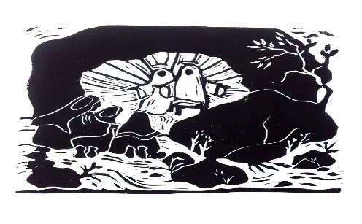
Monday 14th April 6.30pm Evening Service with Church of Scotland at St Andrews
Wednesday April 16th 3.00pm Station of the Cross at All Saints
Maundy Thursday 8.00pm Eucharist, washing & Stripping the Altar at Holy Trinity
Good Friday 12.00 – 2.00pm Silent Prayer and Meditation with Stations of the Cross at Holy Trinity
2.00 to 3.00pm The Final Hour at Holy Trinity & St Andrews
7.00pm ‘Praying Light into the Shadows’ Service at Church of Scotland, Blair Atholl.
Holy Saturday 8.00pm The Easter Vigil at Holy Trinity
Easter Day – Holy Communion at 9.30 Holy Trinity & at 11.15am Kilmaveonaig & St Andrew’s & 7 a.m. Easter Fire at St. Andrew’s.

